**KAMPALA PARENTS’ SCHOOL 2004**

**END OF YEAR ASSESSMENT, 2018**

**NUMBER – TOP CLASS**

**Name: ______________________________ Group: ________**

**Date: ________________________________________________**

1. 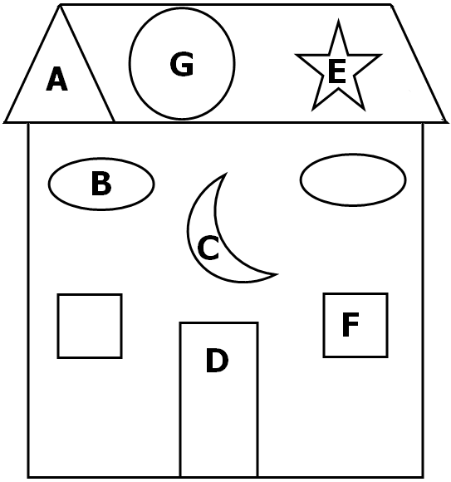**Name the shapes.**

**circle**

**star**

**triangle**

**crescent**

**rectangle**

**oval**

**square**

A **__**t r i a n g l e**___**

B **_________________**

C **_________________**

D **_________________**

E **_________________**

F **_________________**

G **_________________**

1. **Take away**

8 - 3 = 5 4 - 1 = ____

9 - 6 = ____ 10 - 5 = ____

4

- 4_

____

8

- 7_

____

Seven takeaway two equals _________

Ten pencils takeaway six pencils equals _____ pencils

1. **Read and draw**

A full glass of water

Half glass of water

An empty glass of water

1. **Complete the patterns**







1. **Add the numbers**

7 + 2 = 9 2 + 2 = ___ 6 + 1 = ___

4 + 4 + 3 = ___ 5 + 0 + 4 = ___

4

+ 3_

____

8

+ 2_

____



Three plus two equals f i v e

Six plus three equals ______________

Two plus two equals ______________

1. 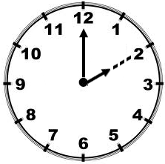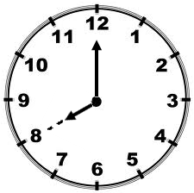**What is the time?**

It is 2 o’clock. _______________________

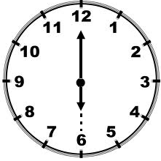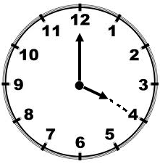

_______________________ _______________________

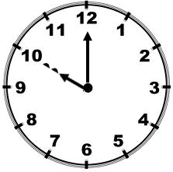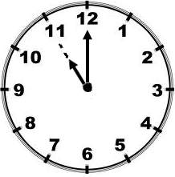

_______________________ _______________________

1. **Write the middle number.**

13 ______ 15 18 ______ 20

9 ______ 11 16 ______ 17

1. **Write the months of the year.**

1st J a n u a r y

2nd ___________________

3rd ___________________

10th ___________________

12th ___________________

6th ___________________

**( December , May , July , January , March , June , November , February , October , April , August , September )**

1. **Write the number names.**

13 t h i r t e e n 8 ___________________

20 ___________________ 15 ___________________

10 ___________________

**( fifteen , twenty , ten , thirteen , eight )**

1. **Fill in correctly**

|  |  |
| --- | --- |
| **Name** | **Picture** |
| Sarah |  |
| Peter |  |
| Jane |  |
| Ann |  |
| Bob |  |
| Ali |  |

Sarah has ________________ apples.

Jane and Bob have ___________ apples altogether.

Peter has ______________ apples.

Ali and Ann have _____________ apples.

How many apples do they have altogether?

___________________________________________________